Automating Data Import and Relationship Mapping Using Import Sets & Dot Walking

Import data from data source

Description
Importing data from a Data Source in ServiceNow means bringing external data (like CSV, Excel, or database records) into the ServiceNow platform so it can be stored, processed, and used within tables such as Incident, User, or any custom table.
In ServiceNow, a Data Source defines where the data is coming from (for example, a CSV file or external database) and how it should be read. Once configured, the system loads the data into an Import Set table, which acts as a temporary staging area. From there, a Transform Map is used to map fields from the Import Set table to the target table. This ensures data is correctly inserted or updated based on defined field mappings and business rules.
This process helps organizations:
- Avoid manual data entry
- Maintain data accuracy and consistency
- Automate recurring data imports
- Integrate ServiceNow with external systems
Overall, importing data through a Data Source provides a structured and scalable way to move external data into ServiceNow efficiently and securely.

Create records in the Sheet

Description

- Open google sheet
- Name the fields as name,email,department, manager and phone number
- Enter some records
- Save the sheet as: employee data
- Download the file as .xlsx , .csv (or) .xml file

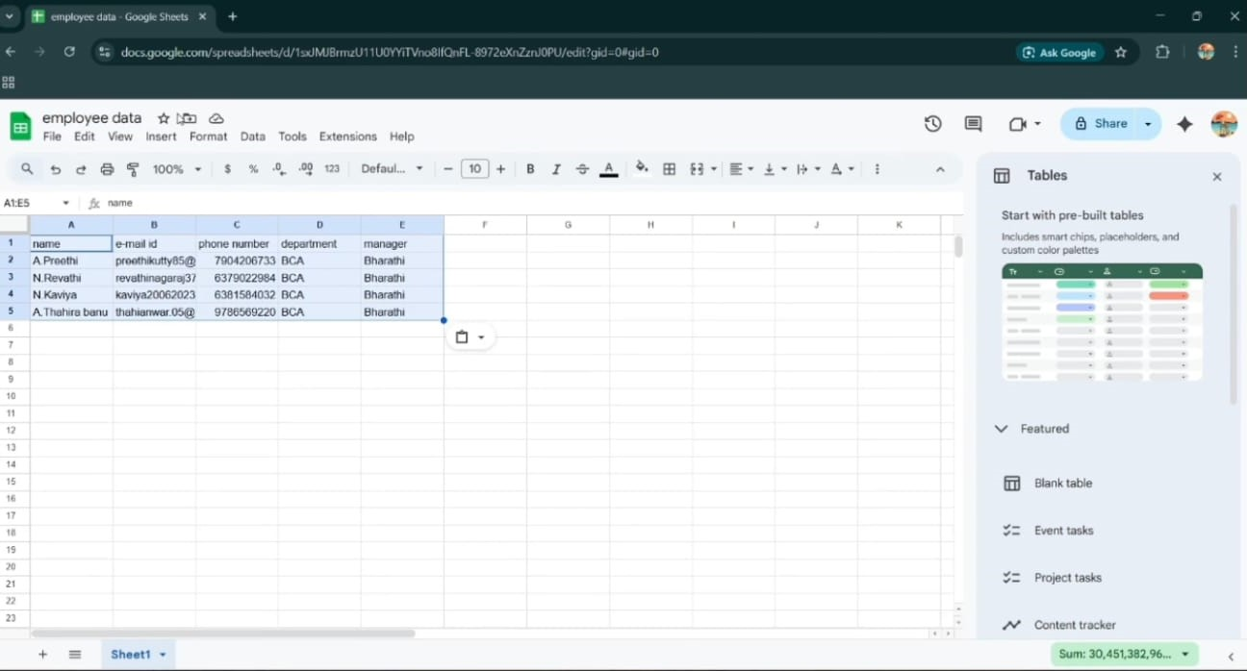

Import data

Description

The Import Data process allows employee records from an external file (CSV or XLSX) to be brought into ServiceNow using the Import Set framework. The uploaded file is first stored in a staging table (Import Set table), where the data can be reviewed and validated before being moved to the target table.
This approach ensures safe data migration by separating raw imported data from production tables like sys_user. It also allows administrators to verify, transform, and control how records are inserted or updated in the system.

Creating Import Table(Staging Table)

Description

- Open service now.
- Click on All >> search for import sets
- Select load data under system import sets
- select create table
- Give the the import set table name as: import employee
- Choose the file which we created in the XL sheet.
- The data is imported,click on personalized list
- Add fields to the form.

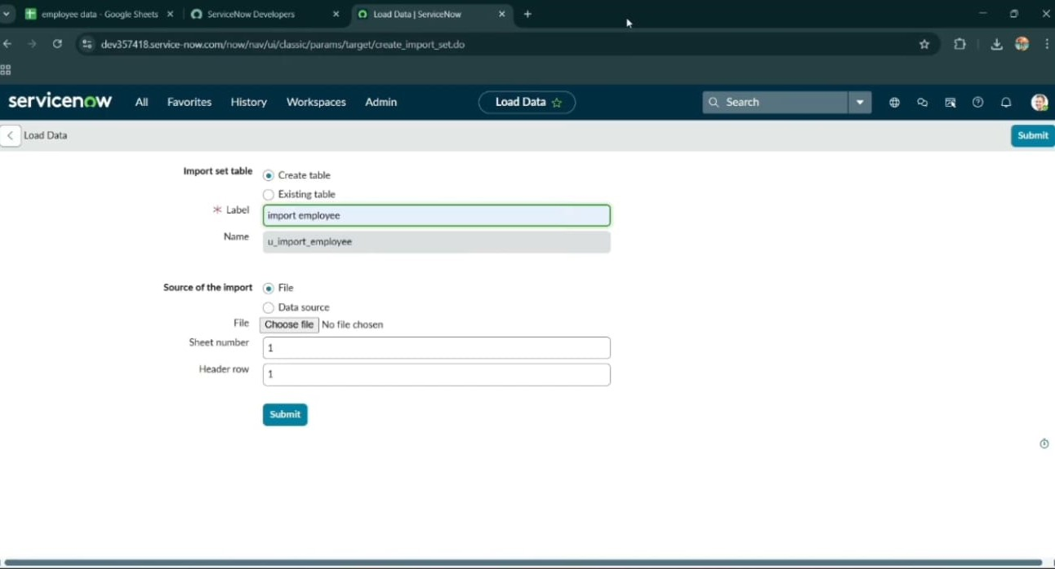

Create transform map

Description

- Open service now.
- Click on All >> search for import set
- Select create transform map under import sets
- Click on new
- Fill the following details to create a new transform map
- Give name as: Test
- Select source table: @123
- Select target table: user[sys_user]
- Save the form. 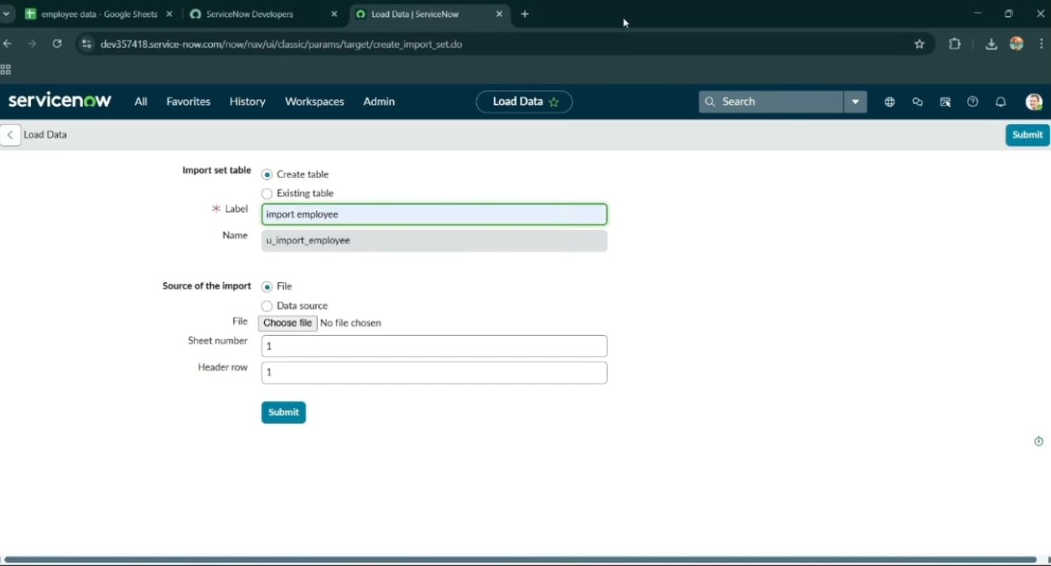

Match the fields using mapping assist

Description

- Scrolled down the created transform map form
- Click on auto matching fields
- Then in the mapping fields some fields are matched
- Using mapping assist map the manager field.
- Select the fields which you are mapping in the staging table and target table
- Select manager in source table and add
- Select manager field in target table
- Click on the save button

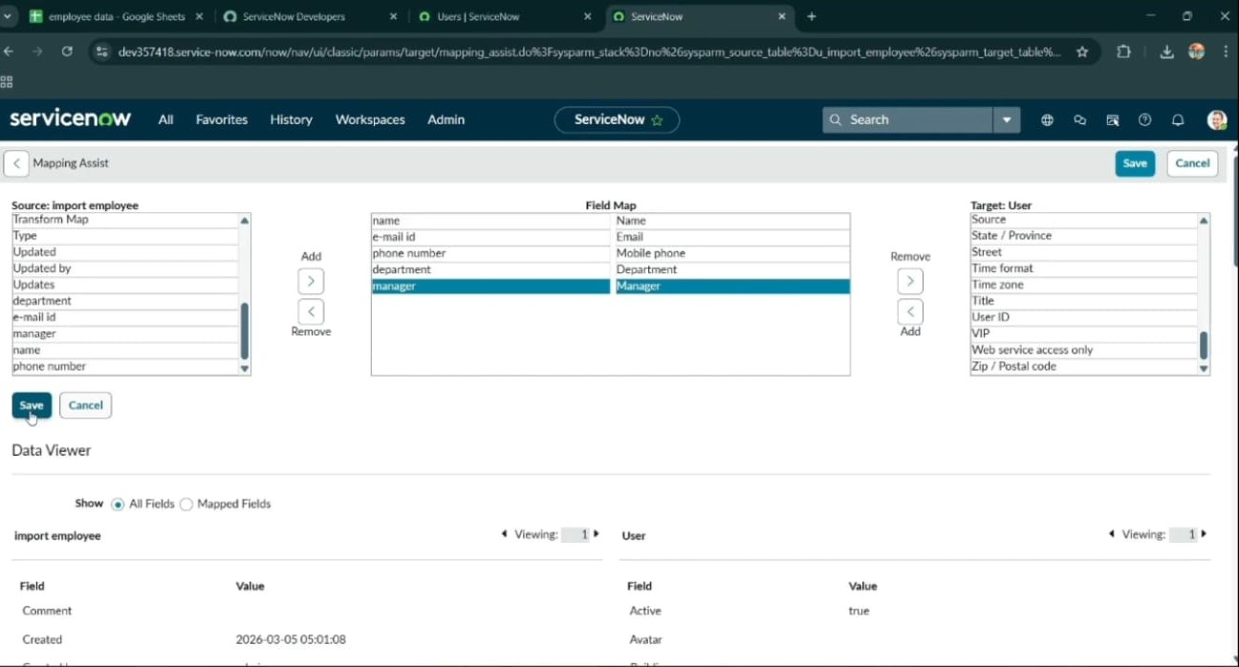

Transform the Data

Description

- Click on transform in the related links.
- Click on transform.
- Data's transform state is completed.

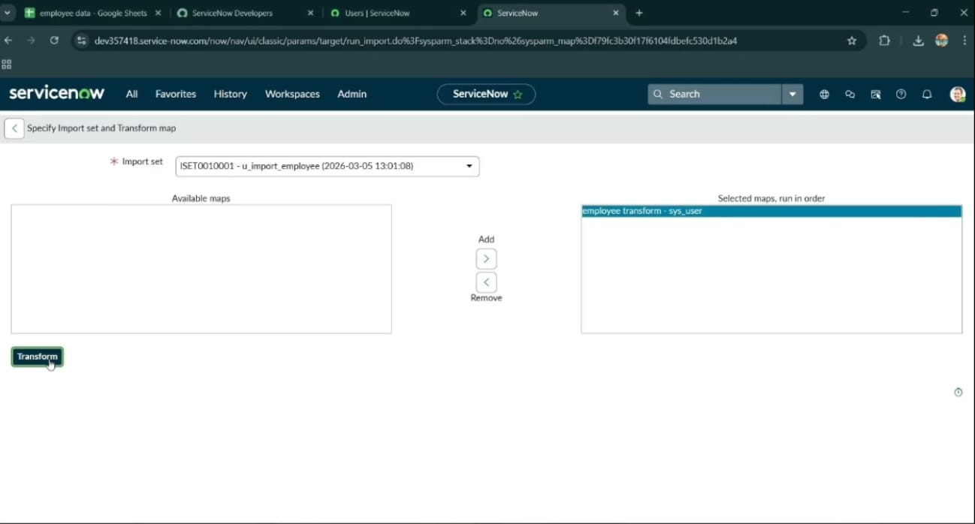

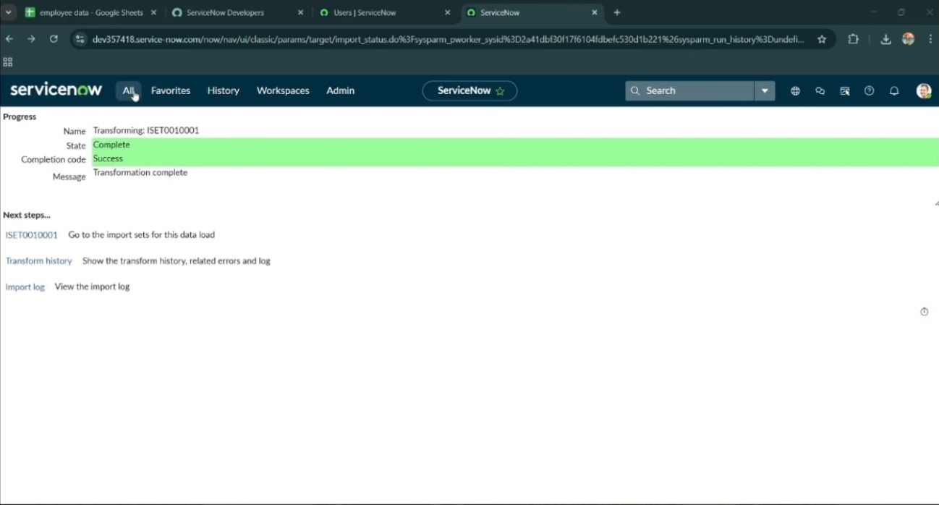
- Click on ISET0010008 under next steps
- Four rows are inserted.

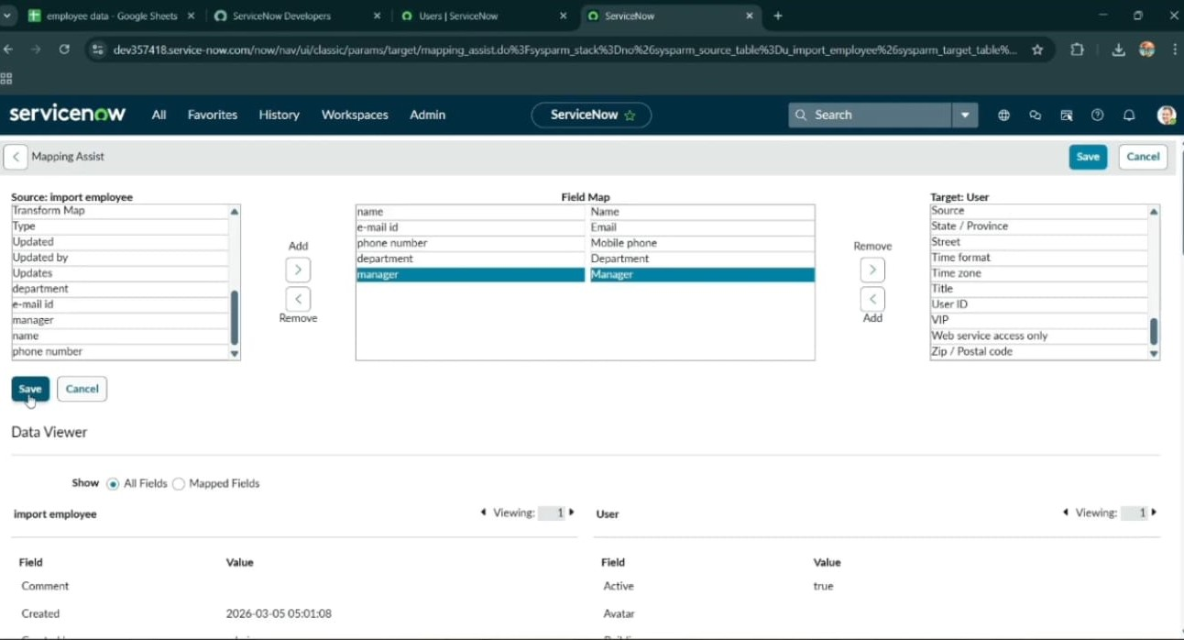

Dot walking

Description

Dot Walking in ServiceNow is a technique used to access fields from a related table using a reference field.
when one table has a reference field pointing to another table, dot walking allows you to retrieve fields from that referenced record without writing complex queries.

Display department to the assigned to user

Description

- Open service now.
- Click on All >> incident
- Select create new under incidents
- There is no field like department in the form
- Email and manager fields are not visible
- By using dot walking retrieve the data without opening the record
- Click on context menu go to configure and select form layout
- Select assigned to.department as mentioned below
- Click on save
- Add another field assignment.email.
- Also add assignment.manager field
- Click on save.

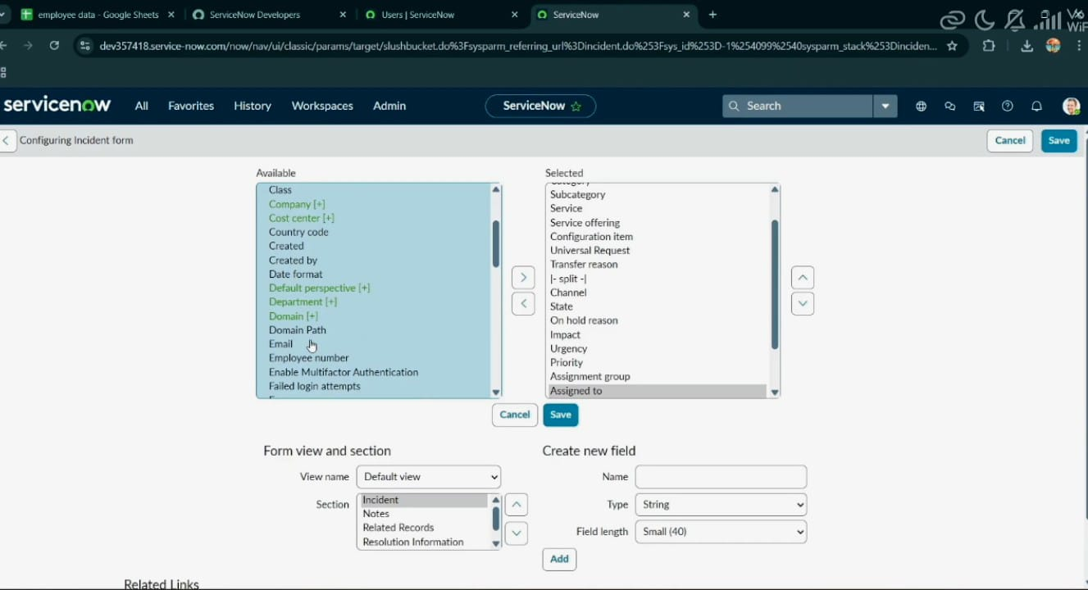

13. Open an incident form
14. Fill the mandatory fields and assigned to just imported user
15. Then department and email field is automatically filled

Testing

Description

Testing is the process of verifying that a system, feature, or functionality works as expected and meets defined requirements before it is released to users.

Conclusion

Description

This project automates data imports using Import Sets, Transform Maps, and Dot Walking in ServiceNow PDI, enabling efficient data migration and relationship mapping.
Import Sets allow easy data import from external sources.
Transform Maps ensure data is correctly mapped and processed.
Dot Walking enables automatic relationship mapping between tables.

